NetGuard AI: A Real-Time Explainable IoT Intrusion Detection System

Rohith S Panchamukhi
Dept. of CSE
RV College of Engineering Bengaluru, India rohithsp.cs24@rvce.edu.in

Rohith Kumar L
Dept. of CSE
RV College of Engineering Bengaluru, India rohithkumarl.cs24@rvce.edu.in

Rahul A S
Dept. of CSE
RV College of Engineering Bengaluru, India rahulas.cs24@rvce.edu.in

Abstract—As the number of connected devices on the Internet rapidly increases, our networks are increasingly exposed to threats. To ensure security, our network approach must be significantly improved in the future. In this study, we developed NetGuard AI, a complete Intrusion Detection System (IDS) for IoT running on physical microcontrollers. We conducted live monitoring and set up a network with three ESP32 nodes. Through conducting this experiment, I discovered that most of the traditional ML models trained on the flows have severe lim-itations in terms of detection abilities for zero-flow and payload attacks, such as the inability to detect the slow-rate attack with zero-flow data and the inability to detect data poisoning with the normal packet timing. Thus, in response to this issue, we proposed the Two-Stage Hybrid Detection Pipeline, which utilizes statistical profiling with Exponential Moving Average (EMA) Z-scores and long-time estimation of packet inter-arrival time (IAT) in Stage 1 and a Random Forest classifier for volumetric, replay, topic-bombing, and evasive attacks in Stage 2. As we obtained a 99.20% accuracy on seven different behavioral states, and since machine learning is somewhat of a ”black-box” we wanted to be able to interpret why these decisions were made. Therefore, we designed three levels of Explainable AI (XAI) stack, where the local decision explanation is performed by SHapley Additive exPlanations(SHAP), and these SHAP values are consumed by a Large Language Model (LLM)-powered Retrieval-Augmented Generation (RAG) pipeline that generates human-readable incident reports through a secure API cascade. These findings, along with live data, explanations, and physical node states, are presented on our custom-built web-based SOC.
Index Terms—Intrusion Detection, Explainable AI, Internet of Things, Machine Learning, Security Operations Center, Random Forest, RAG, Z-Score, Hybrid Pipeline

- Introduction
Today’s IoT connects the physical and digital world for intelligent automation and monitoring [1]. The catch is, most edge devices are small and don’t have lots of resources. They are very limited in terms of memory, and they don’t have that much processing power even for simple things. So we can’t easily attach lots of encryption or use standard security software on them [2]. For this reason, IoT environments are the next biggest target, with everything ranging from enormous denial of service floods and unobtrusive slow-rate attacks to attackers altering sensor payloads. [3].
In a typical IDS, one solution to this problem would be looking for a specific attack signature. Of course this requires that you’ve seen this attack before; otherwise it can be easily
circumvented [4]. ML can find the odd network behaviors far better as it examines the intricate patterns [5].However, ML models are essentially black boxes. ML models may tell you there is an attack taking place but will not provide the reasons for it to do so. We interviewed individuals within a SOC, and it became clear that the output of a ”yes/no” alert is not sufficient for individuals working within a SOC. They require an immediate explanation to the occurring issues in order to mitigate the incident effectively [6].
We also observed that traditional supervised ML models-which generally examine traffic within 10 second intervals-possess significant limitations. A Slow Rate attack could simply bypass such a model by only submitting a malicious packet every 15-30 seconds; it would be completely missed since the 10-second windows in between packets would appear empty and otherwisenormal. This also occurs in the case of Data Poisoning attacks, where the attacker submits false sensor readings but maintainseactly the same packet timing as the device it aims to mimic; thus, the flow features are identical. We developed NetGuard AI to address some of these shortcomings. It’s a combined hardware and software system which we created to act as a real-time IDS for the IoT. Unlike many papers which test only offline against historical datasets [7], we set up a physical network of ESP32 microcontrollers sending MQTT messages through a cloud broker in order to
process live traffic.
The primary contribution that we make is the Two-Stage Hybrid Detection Pipeline. For Stage 1 we have a completely unsupervised Statistical Profiler that focuses on watching packet gaps in the short to medium term so as to not let those Slow Rate attacks through, and we include an EMA Z-score check on the actual sensor readings to mitigate Data Poisoning. A packet that survives this check without triggering it will go into Stage 2: a Random Forest Classifier that operates on 10 features we designed for the flow; I have tested this algorithm and find it to be very accurate with a 99.20% accuracy across 7 different states.
One of the key features that we implemented was a three-tiered Explainable AI (XAI) stack. We take SHapley Additive exPlanations (SHAP) locally and feed them into a RAG system, using a LLM [8]. Essentially, the system takes the complex math from the model and writes it out as an easily

readable summary incident report. We stream all of this directly to a web dashboard so you are able to monitor the network live.
- Related Work
There’s been significant research into IoT security, Machine learning, and Explainable AI recently. In our project, we aim to build upon, and possibly improve, four key aspects from the literature.
- IoT Security and Intrusion Detection
We all are aware that some protocols have very peculiar weaknesses such as MQTT and CoAP. A recent security analysis on vulnerabilities [3] has revealed that MQTT brokers are susceptible to both packet flooding and payload injection attacks. Early IoT IDS systems were primarily designed as simple rule based systems [13]. Such systems are poor in detecting zero-day and slow rate attacks [15] and possess poor false negative rates. To overcome such deficiencies, in our proposed NetGuard AI system, we integrated behavioral flow features with statistical check on payloads. We consider that such approaches help us to protect from both network level and application level threats.
- Machine Learning in Network Security
Ensemble learning for network security is extremely effec-tive. If you look at the papers that evaluated performance on benchmark data, decision tree approaches like Random Forests and Gradient Boosting are consistently suggested as the best option when it comes to dealing with highly noisy, high dimensional data obtained from network traffic [4]. And hybrid/ensemble models have already been demonstrated to perform better than individual models when trying to detect ”abnormal” IoT anomalies [11]. What bothered us in existing literature was that all of these methods were evaluated against static, offline data only. We decided to see how well these methods performed in the real world, where we deployed and tested against real, live traffic obtained directly from hardware and covered 7 states.
- Explainable AI (XAI) in Cybersecurity
In the context of security, nobody would ever rely on a black-box ML model in an important security-related setting. Things turned out to be different, since SHAP feature attri-bution [5] became publicly available, it gave a mathematical guarantee on the detection of the adversarial attacks. Recently, people began to apply SHAP to the domain of IDS like: measuring a multi-class drone intrusion [14] or performing federated learning in a heterogeneous IoT setting [6]. Never-theless, the major problem relies in the computation time to compute such explanations at runtime (which would lead to the blocking of the system). To overcome this problem, we executed theTreeExplainerin an asynchronous thread-pool and computed the local explanation as quickly as possible without having the FastAPI server blocking.
- LLMs and RAG in Security Operations
This approach of integrating LLMs into SOC operations is still relatively novel. Previous automated reporting tools tend to be just template fillers and do not provide the necessary context. In recent work, several researchers have demonstrated that LLMs can actually assist in the analysis of threat intelli-gence and reading logs [8]–[10]. We simply can’t provide raw network data as input to an LLM, because the result will be entirely hallucinated. We combat this issue by building on top of a RAG architecture [7]. We pin down the prompt given to the LLM using real mathematics from the SHAP values, the current feature vectors, and a local knowledge base. It acts like an automated Tier-1 analyst but stays factual.
- Design and Implementation
We divided the NetGuard AI system into three major parts: physical hardware edge, Python FastAPI backend, and Next.js front-end. To ensure speed of data transit, simple MQTT pub/sub mechanism was employed. As you can see in Fig how it is all wired up together: 1.
- Hardware Edge Layer
For the physical edge, I set up three different ESP32 microcontrollers (Tensilica Xtensa LX6) talking over Wi-Fi:
  - ESP321 (Environmental Node): This one connects to a DHT22 sensor and sends out temperature and humidity data. We programmed it to publish every 2 to 5 seconds. I also added some random jitter to the timing because real IoT devices almost never sync up perfectly.
  - ESP322 (Ambient Node): I wired up a Light Dependent Resistor (LDR) in a simple voltage divider here to track ambient light. The readings naturally go up and down with the time of day, which gives us a great baseline for what normal traffic looks like.
  - ESP323 (Attacker Simulator Node): This is the fun one. It has a 16×2 I2C LCD and a physical push-button hooked up to a debounced interrupt on GPIO 14. When you press the button, it cycles through seven different
attack modes, like DoS Floods, Replay attacks, and Data Poisoning. It also listens to the netguard/alerts MQTT topic. If it hears that an attack was detected, a hardware interrupt fires off, triggering a loud piezo buzzer and flashing a red LED for a few seconds.
- Backend Processing Engine
The backend was written in python with FastAPI and we have a Paho-MQTT client just lying dormant and listening on the netguard/# wildcard topic over the public HiveMQ broker. All the packets coming in to the queue are just chucked into a 60s memory buffer using a collections.deque.
The async loop runs every 5s, taking the last 10s of packets, and feeding that through the feature extraction, and through our Two-Stage Hybrid Detection Pipeline. The main problem I faced is that the ML inference, along with all the SHAP math, is quite compute intensive. This meant that running these on the main thread would cause the asyncio

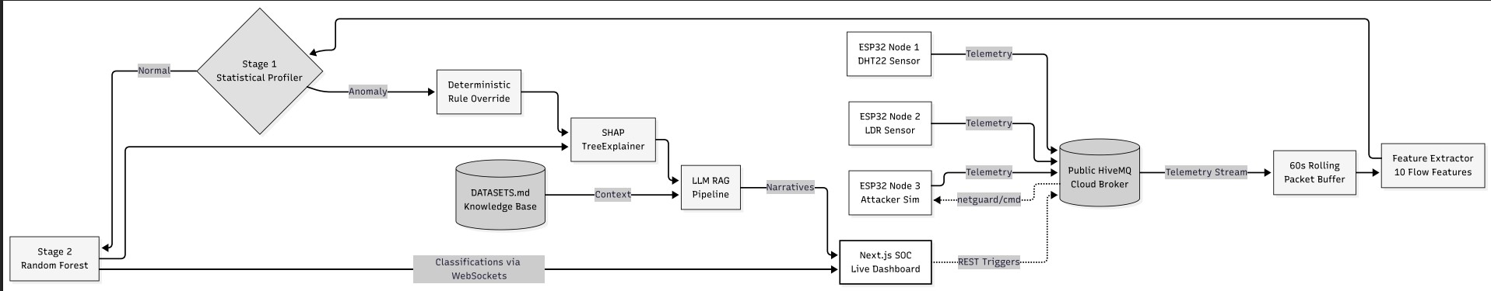

Fig. 1. NetGuard AI System Architecture. Physical nodes stream telemetry via MQTT to the FastAPI backend, which handles ML inference, SHAP computation, and RAG generation before streaming to the SOC dashboard.
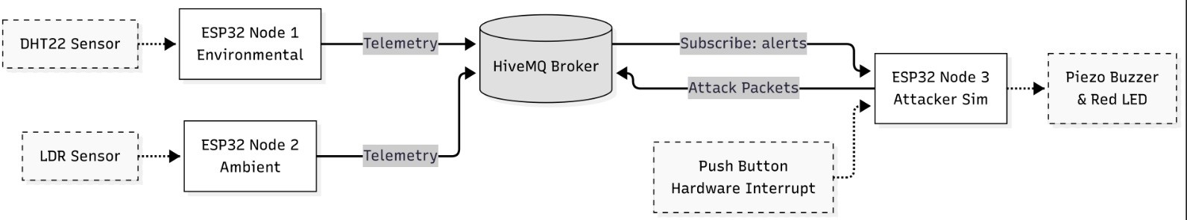

Fig. 2. Hardware architecture of the proposed IoT-based intrusion detection system

loop to get stuck and randomly disconnect our WebSocket connections. As a result, all the work for the Random Forest and SHAP, is handled off on the thread pool background using asyncio.to_thread().
- Frontend Presentation Layer
For the SOC dashboard we decided on using React 19, and Next 15. The frontend basically just makes one Web-Socket connection to the backend using a custom hook called useLiveData. This hook handles all incoming data, feeding it into the scrolling packet feed, the charts, the anomaly graphs, as well as a small SVG map of the network topology with almost zero lag. Additionally we have some REST endpoints such that by pressing a button on the dashboard we can initiate an attack, which seamlessly keeps itself synchronized with the physical LCD screen of the ESP32.
- Methodology
- Data Collection and Feature Engineering
If you try to train an ML model straight on raw packet pay-loads, you’re going to end up overfitting. Plus, it’s completely useless if the traffic is encrypted. That’s why we focused on behavioral flow features instead. We look at a 10-second sliding window of traffic and shift it forward every 5 seconds. For each of these windows, we pull out 10 specific stats:
  - Packet Count (N ): How many packets arrived.
  - Packet Rate (R_{pkt}): Packets per second (N/windowsize).
  - Mean Inter-Arrival Time (µ_{iat}): The average gap between packets in milliseconds.
  - Standard Deviation of Inter-Arrival Time (σ_{iat}): How much those gaps vary.
  - Minimum Inter-Arrival Time (min_{iat}): The shortest gap we saw.
  - Maximum Inter-Arrival Time (max_{iat}): The longest gap.
  - Duplicate Ratio (R_{dup}): The fraction of sequence num-bers that were repeats (N_{dup}/N ).
  - Sequence Increment Mean (µ_{∆seq}): The average jump between sequence numbers (seq_{i+1} − seq_{i}).
  - Sequence Increment Standard Deviation (σ_{∆seq}): The
variance of those sequence jumps.
  - Unique Modes (M_{uniq}): The number of different device state strings in the window.
Edge Case Handling:This was a little more of a pain to do for the Slow-Rate attack type. The attacks normally send only a single packet ever 15 or 30 seconds. Since the algorithm had a 10sec window that only captures one packet, then trying to take the mean and variance of the numbers would fail. To overcome this I have built the algorithm to detect when there is only a single packet and input the entire window length (10, 000ms) as the inter-arrival time. Distorting the math in this way gives the perfect fingerprint for the model to easily determine stealthy probes. You can clearly see all of our classes plotted with our training data. Fig. 3.
- Two-Stage Hybrid Detection Pipeline
Since the regular ML classifiers are entirely unaware of certain anomalies, we created a series of checks which we are referring to as The Two-Stage Hybrid Detection Pipeline.
  - Stage 1: Unsupervised Statistical Profiler: It’s like hav-ing a doorman for the Statistical Profiler, that doesn’t even require any training! It simply does the calculations, checks for two specific issues before your ML ever runs:

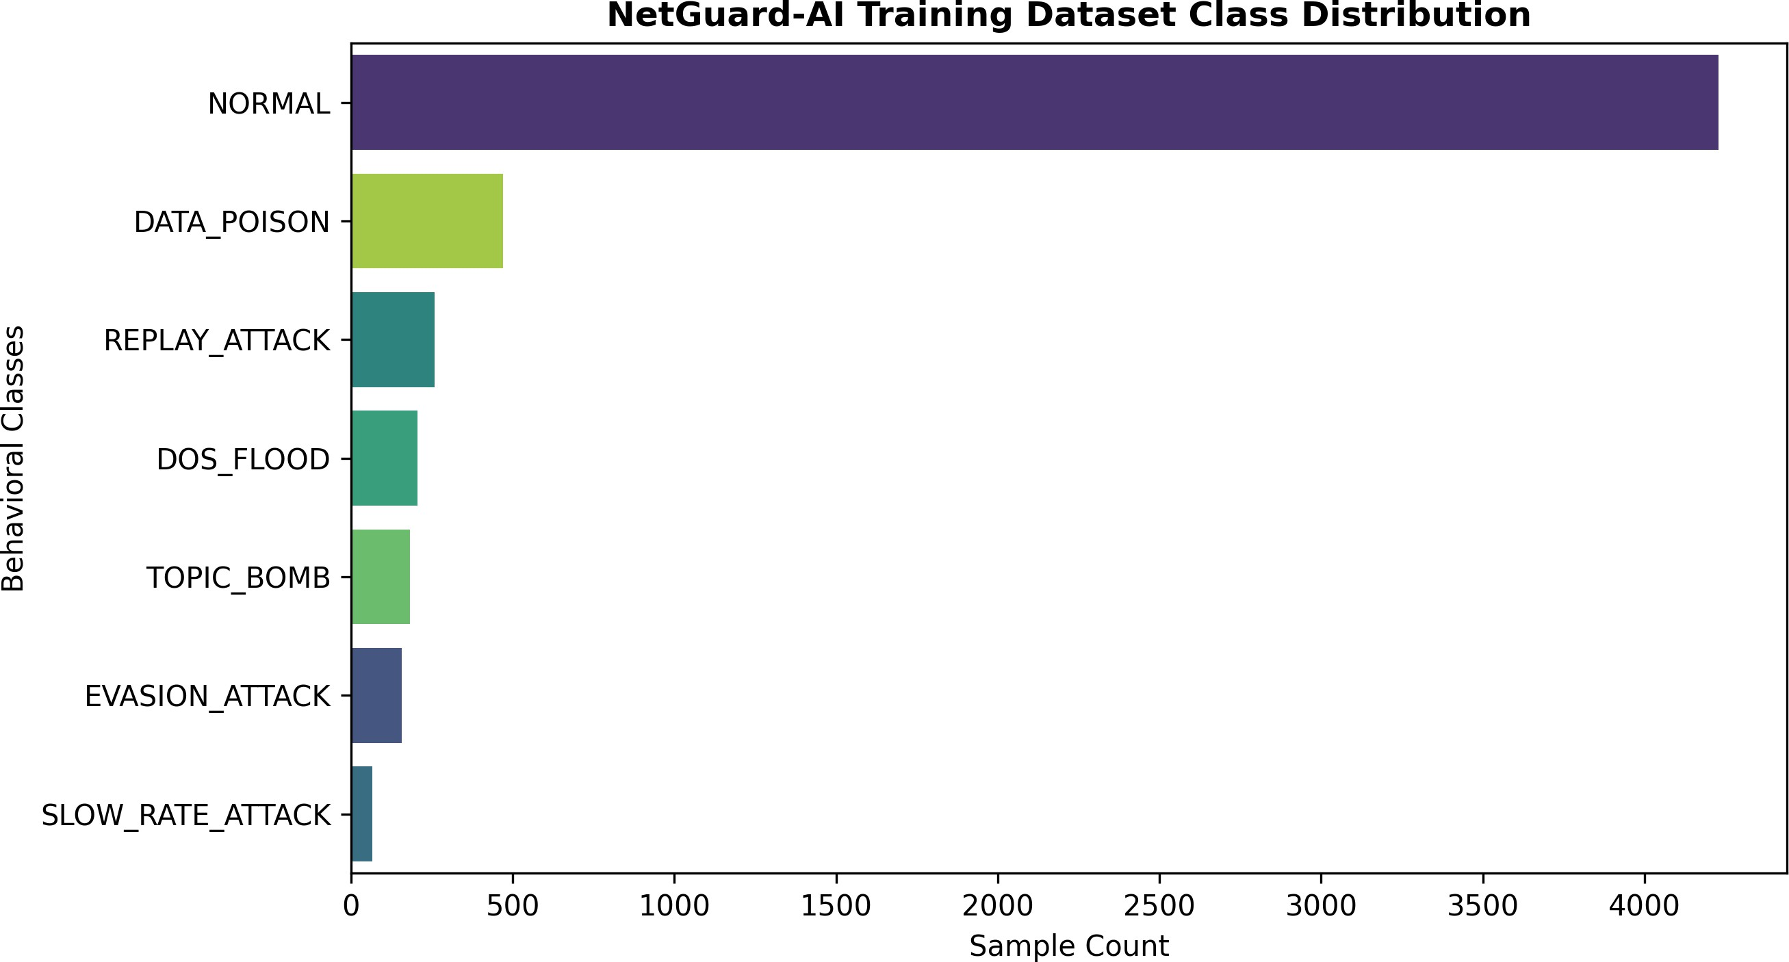
for i ∈ {1, . . . , M − 1}. We then just find the median of those gaps:

Fig. 3. Distribution of the collected training dataset across the behavioral classes, highlighting the dominance of legitimate and normal traffic baselines.

- Detecting data poisoning (EMA Z-Score) Now con-sider an attacker mimicking a legitimate sensor and inject-ing outrageous data (e.g., temperature 999◦C). Because the attacker’s packets are correctly timed, the flow-based ML is going to miss it completely. I thought I would tackle this issue by computing an Exponential Moving Average (EMA) and Exponential Moving Variance (EMV) on real sensor data. Letting x_{t} be the current temperature received at time t, we can define the baseline standard deviation as:
√

σ_{t−1} = max EMV_{t−1}, 1.0 (1)
Then we check the Z-Score Z_{t} of that reading against the baseline we’ve built up:
Median IAT = Median ({IAT₁, . . . , IAT_{M−1}}) (6)
If that median is ridiculously high-over 10,000 ms, and packet rate is less than 0.4-then the system simply disregards all of the other parameters and flags it as a SLOW_RATE_ATTACK.
- Stage 2: Supervised Random Forest Classifier: Given the packets make it through the Stage 1 check, we feed the 10 features into a Random Forest Classifier. I built a 200 estimator Random Forest Classifier trained on data that I collected by actually running the hardware, with the inclusion of a moderate amount of synthetic Slow-Rate data in the training set to even out the class imbalance. I managed to get 99.20
- Results and Analysis
If you look at the Behavioral Confusion Matrix in Fig. 4, it’s pretty clear that the model knows how to tell the difference between normal traffic and an actual attack.

Z_{t} =
|x_{t} − EMA_{t−1}|

σt−1

(2)

So when the Zt is greater than 3.0 then we know something is going wrong, the packets is immediately recognized as a DATA_POISON attack. I need to fix the parameter update while any outliers occur, or otherwise a clever attacker can gradually adjust the parameters until these abnormal numbers look normal. Here’s the way to update it.

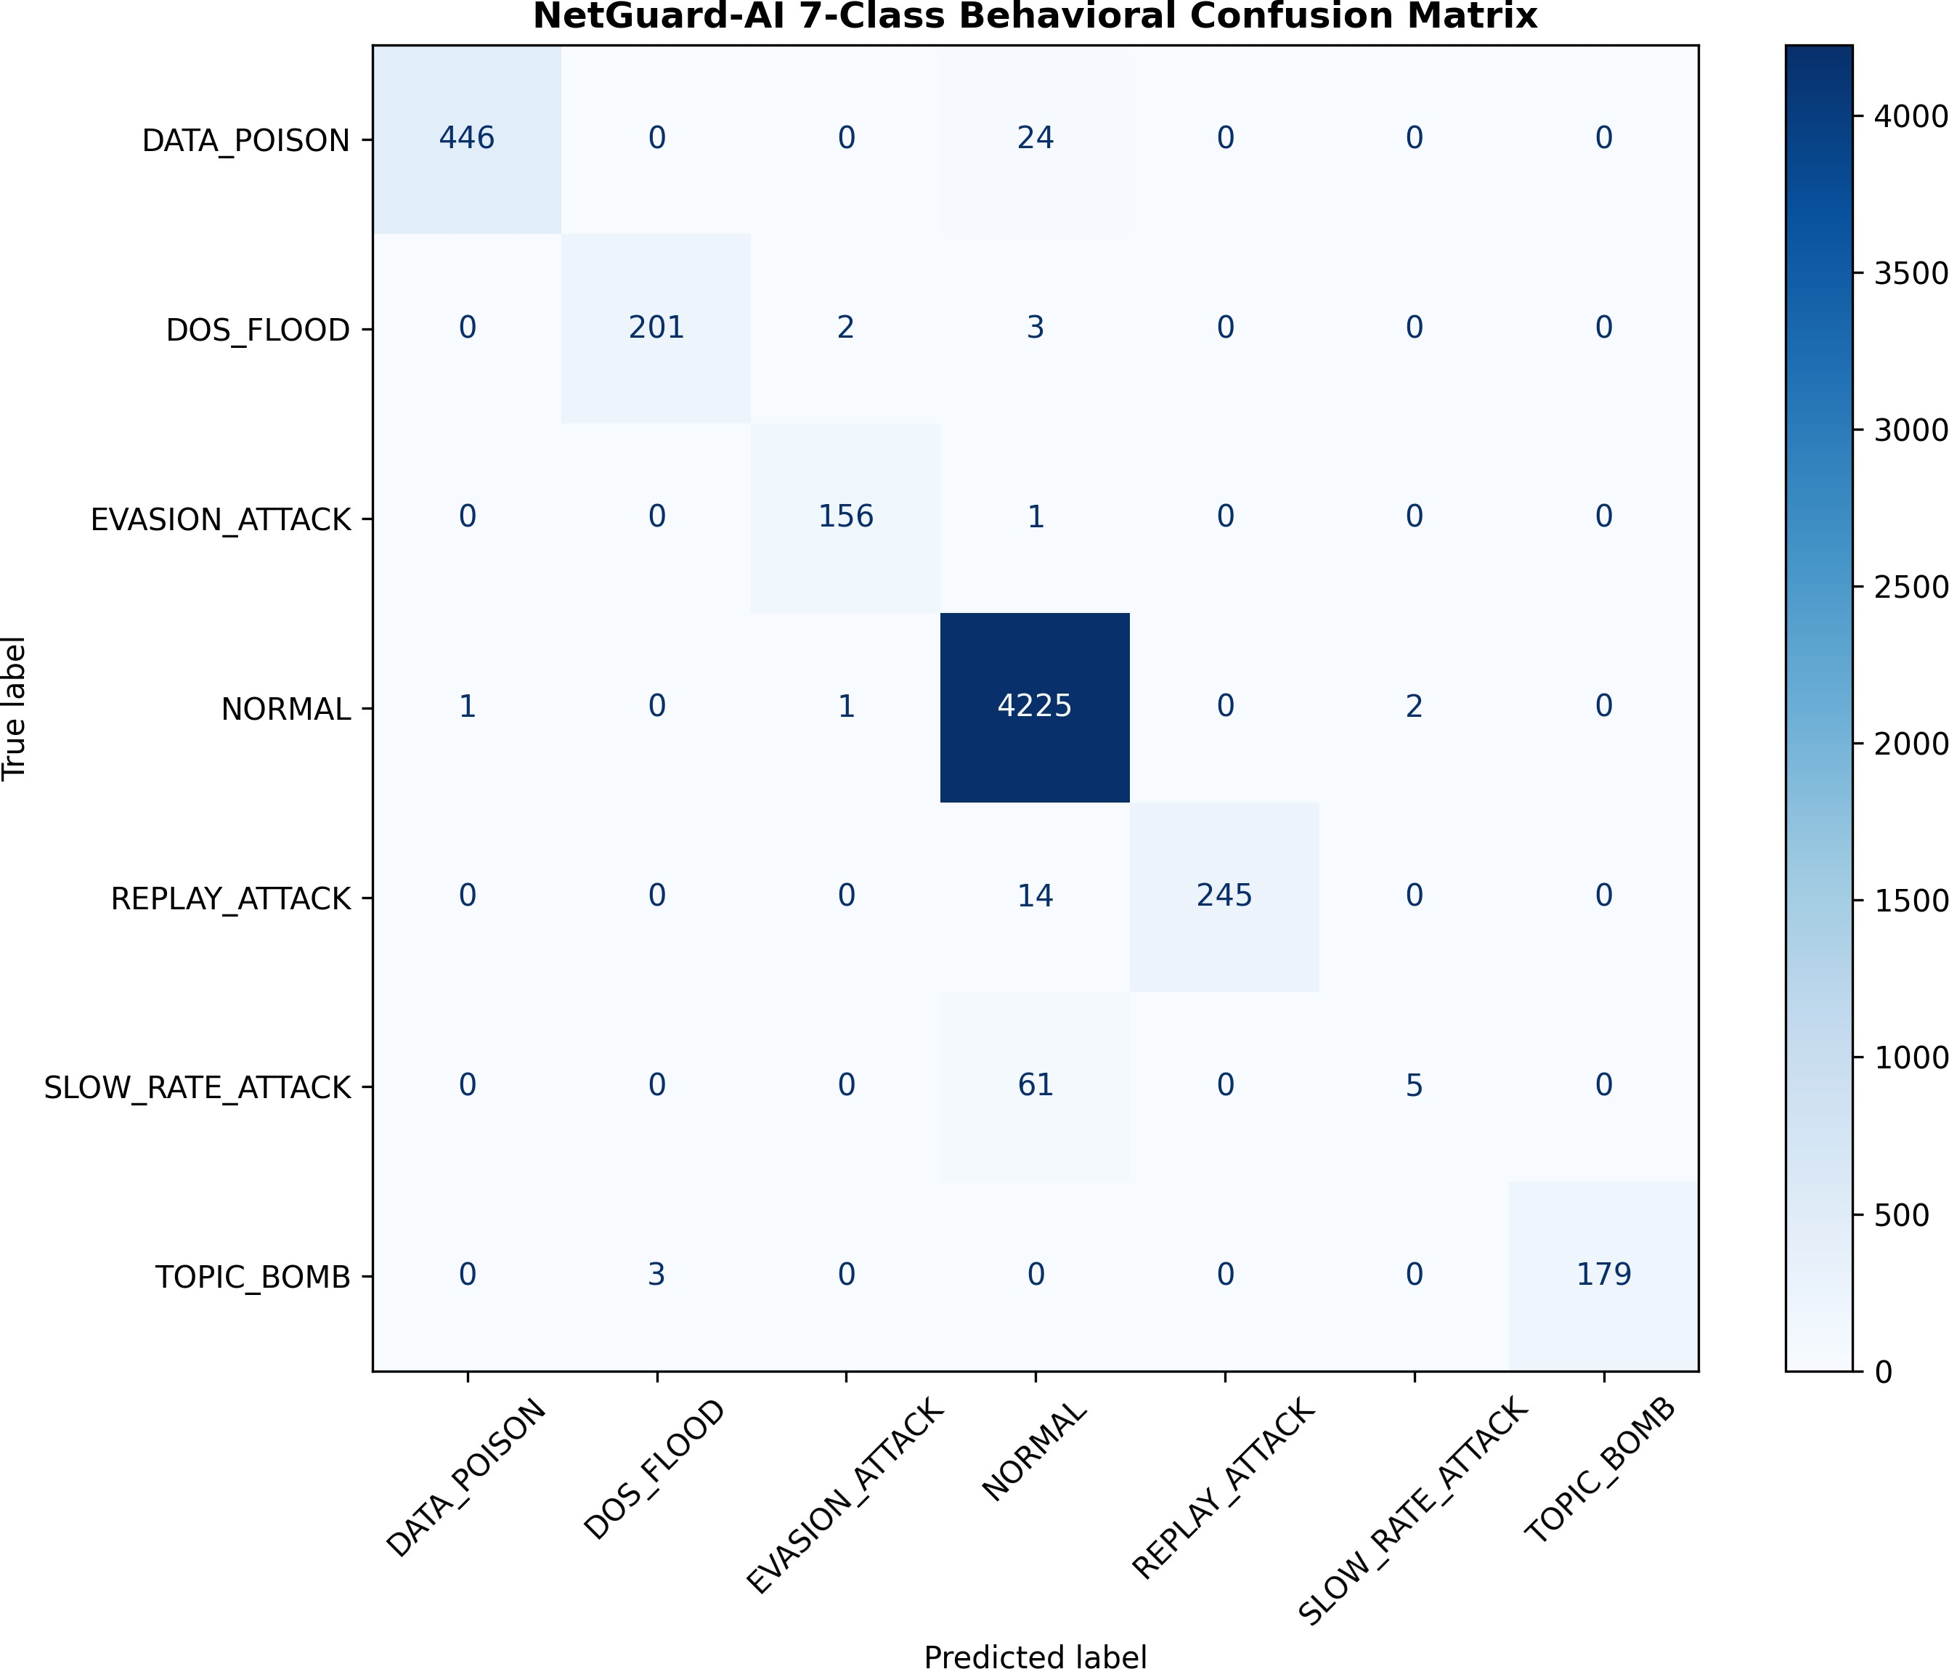
Fig. 4. Behavioral Confusion Matrix showing the model’s high precision and recall across all attack vectors, achieving an aggregate accuracy of 99.20%.

$EMA_{t}=\left\{\begin{aligned}EMA_{t-1}+α\left(x_{t}-EMA_{t-1}\right), if Z_{t} <3.0 & \\ EMA_{t-1}, if { Z}_{t}≥ 3.0 &\end{aligned}\right.$

$$EMV_{t}=\left\{\begin{aligned}\left(1-α\right)(EMV_{t-1}+α{\left(x_{t}-EMA_{t-1}\right)}^{2}) , if Z_{t} <3.0 & \\ EMV_{t-1}, if Z_{t} ≥3.0 &\end{aligned}\right.$$

  - Slow-Rate Attack Detection (Global IAT Tracker): As we discussed above, ML is easily fooled by Slow-Rate attacks due to the large intervals between packets. In order to detect these attacks, Stage 1 maintains a global queue of the M=5 most recent timestamps recorded by the broker, and
represented by the array, t = {t1, t2, . . . , t_{M} }. The intervals between these points in time are computed as:
IAT_{i} = (t_{i+1} − t_{i}) × 1000 (ms) (5)
attacks from our baseline traffic.
The results really show that the model learned the right behaviors. It nails DoS Floods every time because the packet rate goes through the roof and the arrival times drop to almost zero. It also does a great job separating Replay and Slow Rate attacks from our baseline traffic.
However it’s not only about having a good accuracy. What it is truly remarkable, in my opinion is the fact that we succeeded to implement XAI live with three layers.Global Feature Importance and Interactions
By calculating the average Gini impurity over the 200 decision trees, we can understand exactly what the model prioritizes. This is depicted in Fig. 5. Because we don’t examine inside the packet payloads, the model can only consider behavior, and it’s the packetcount (18.65

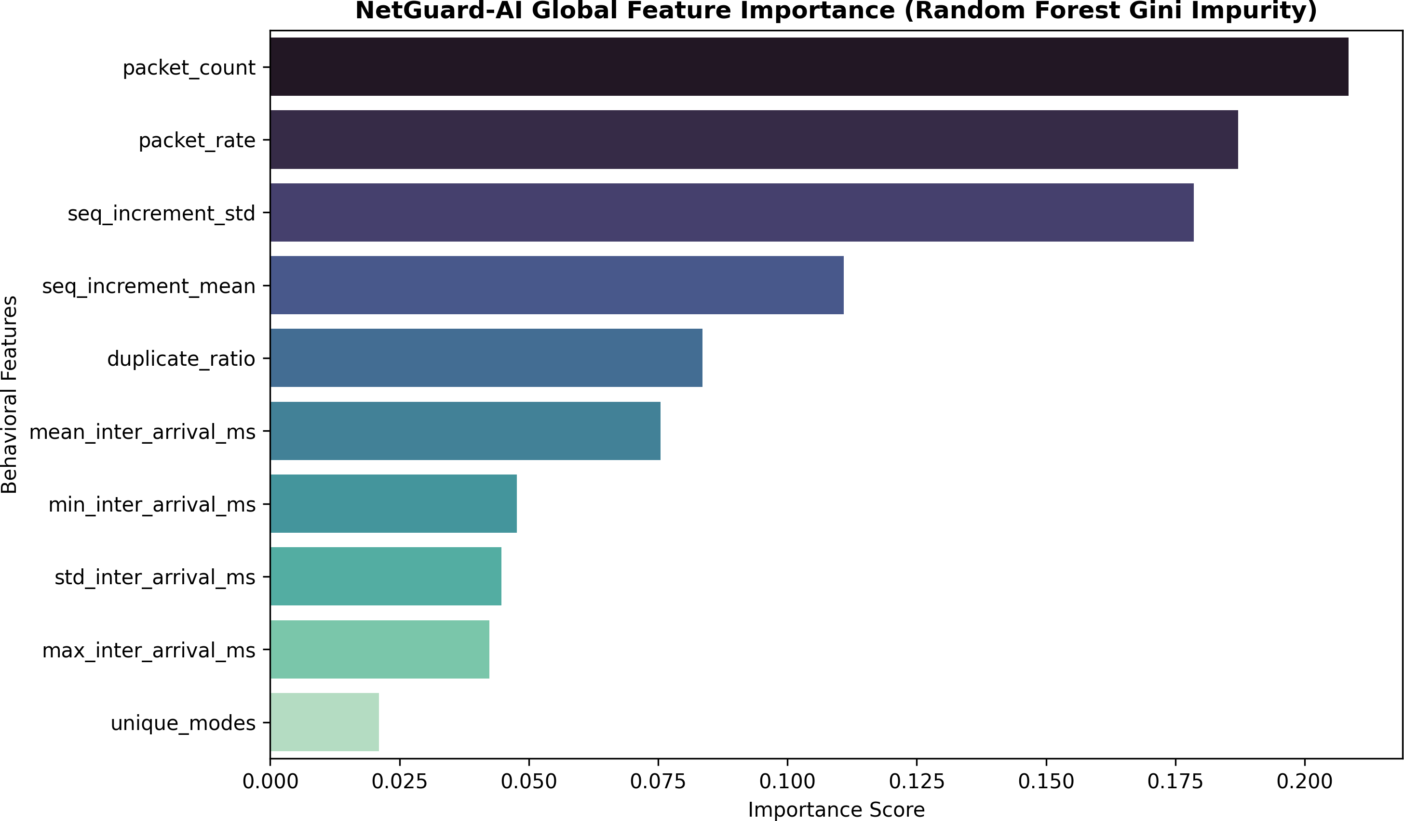

Fig. 5. Global Feature Importance derived from the Random Forest model, indicating the dominance of volume and timing features.

The SHAP Beeswarm plot in Fig. 6 backs this up. It maps out how these features interact. You can clearly see how crazy high values in packet_rate or std_inter_arrival_ms basically force the model to sound the alarm.
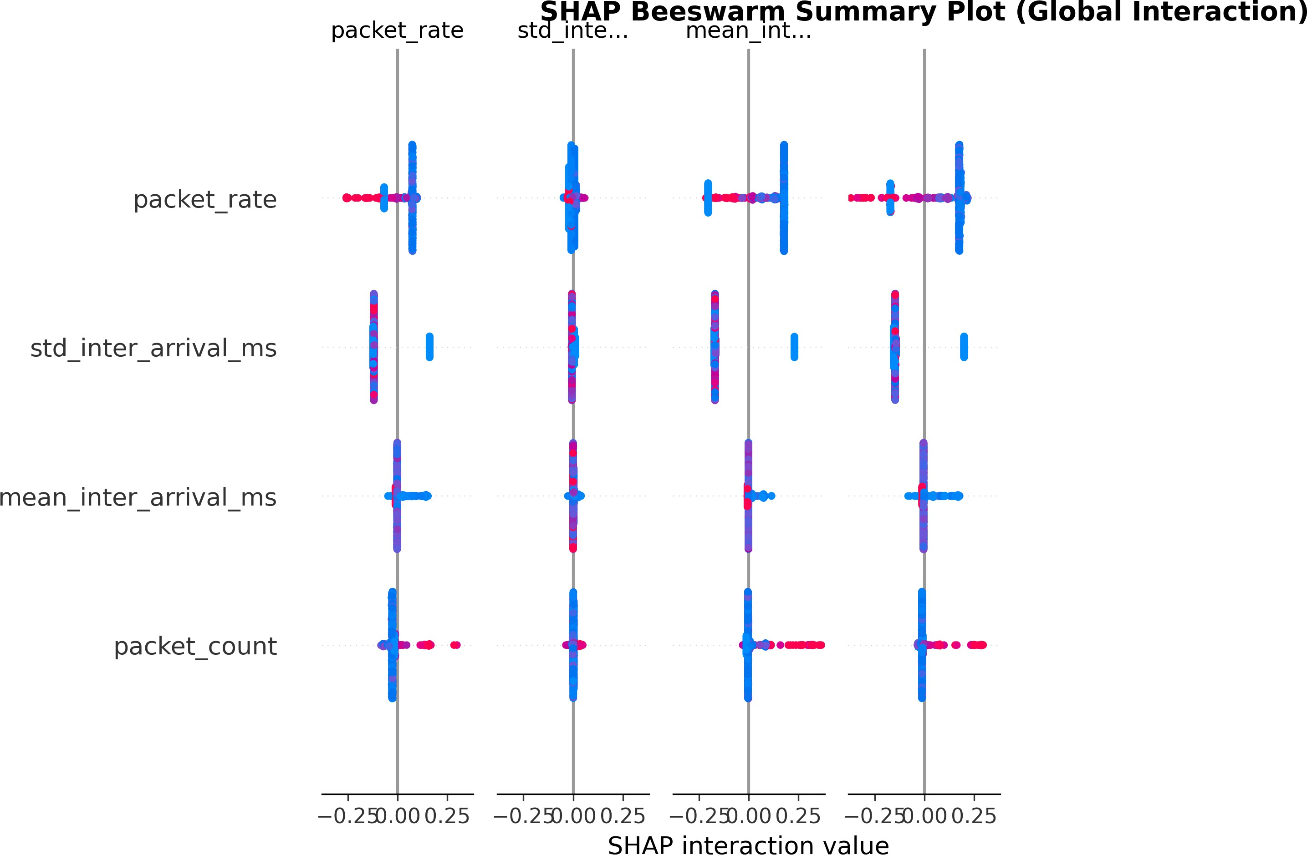
Fig. 6. SHAP Beeswarm Summary Plot illustrating the non-linear impact and interaction of key features on the model’s predictions.

- Local SHAP Inference Profiling
While it’s useful to know what the model is looking for in general, it’s not very useful to know if you’re working at a SOC, and why this particular packet was classified as an attack right then. We resolved this by applying the live features to a shap.TreeExplainer every 5 seconds, which spits out the weights for all of the features. If the weight is positive it’s considered an attack and negative values mean that it’s not.
We captured some of these local explanations for the different attacks in Figures 7 through 10 and 11 through 13:
  - DoS Flood (Fig. 7): The model is 100% sure it’s an attack, and it’s almost entirely because packet_rate (+0.301) and packet_count (+0.285) are maxed out. It’s a classic flood.
  - Replay Attack (Fig. 8): The volume doesn’t mat-ter here. I noticed the model keys in hard on the duplicate_ratio (it hits 1.0, adding +0.333) and
sees the seq_increment_mean stuck at 0.0. It’s ob-vious someone is just playing back old packets.
  - Slow Rate Attack (Fig. 9): Even though there’s hardly any traffic, the model spots the fake 10,000 ms mean_inter_arrival_ms (+0.115) we injected ear-lier. Our Stage 1 profiler actually catches this first and just hands the label down to the model.
  - Normal Baseline (Fig. 10): Everything looks good here. The packet frequencies are normal and the timing gaps are exactly what we’d expect.
  - Data Poisoning (Fig. 11): The ML features wouldn’t normally catch this, so our profiler overrides the decision. The model just sees the rule-engine override signature telling it that the sensor values are impossible.
  - Topic Bombing (Fig. 12): You can see the model freaking out over the massive number of unique topics (the unique_modes feature), right alongside the huge packet count.
  - Evasion Attack (Fig. 13): The attacker tries to hide the flood by using random delays, but that actually backfires. The model spots the wild variability in std_inter_arrival_ms and flags it anyway.

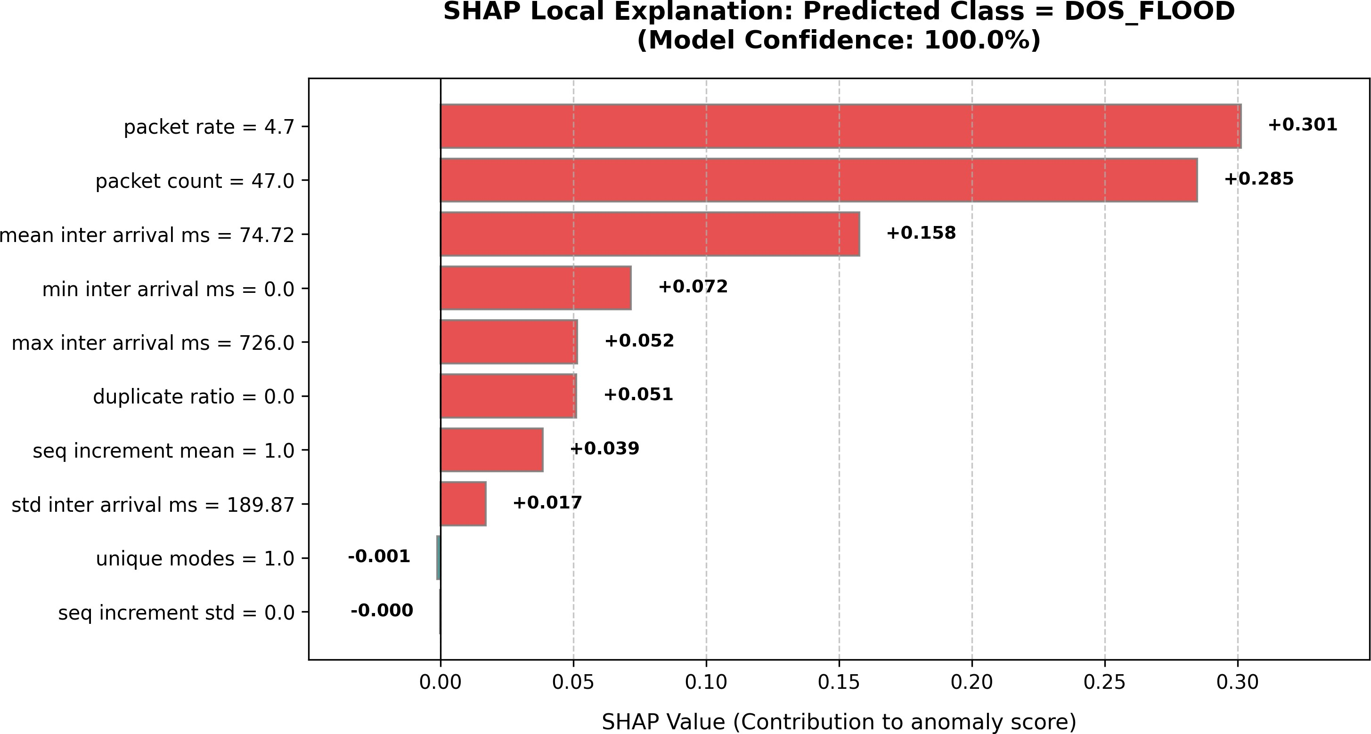

Fig. 7. Local SHAP explanation for a DoS Flood attack, driven by volumetric packet count and rate features.

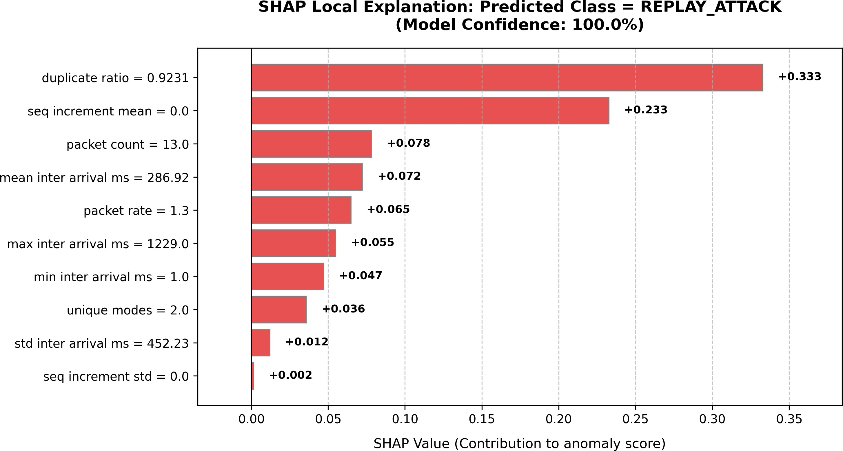

Fig. 8. Local SHAP explanation for a Replay Attack, dominated by the sequence duplicate ratio.

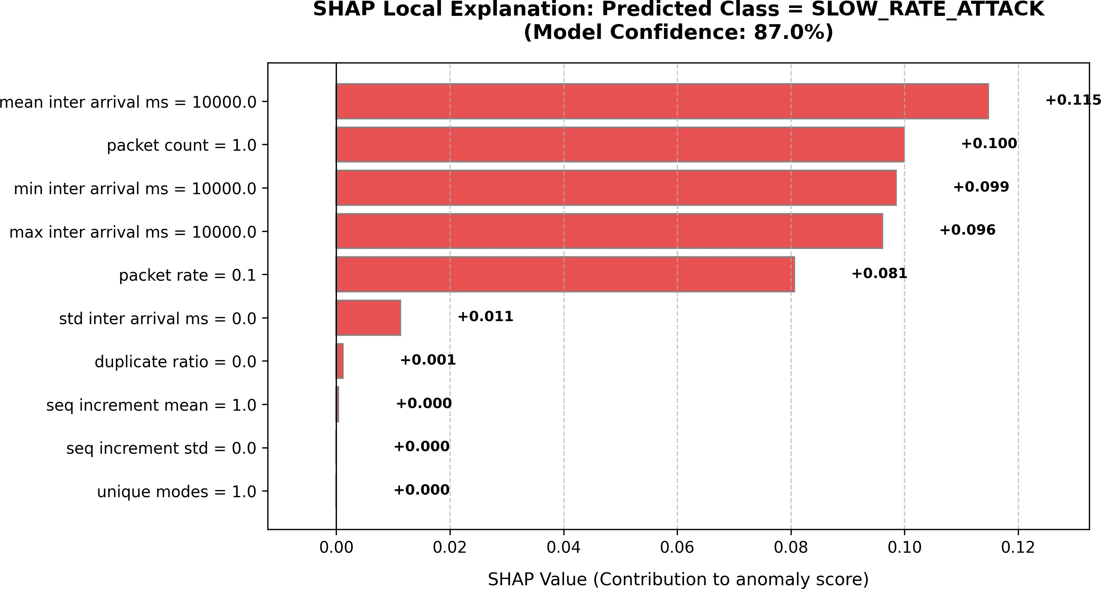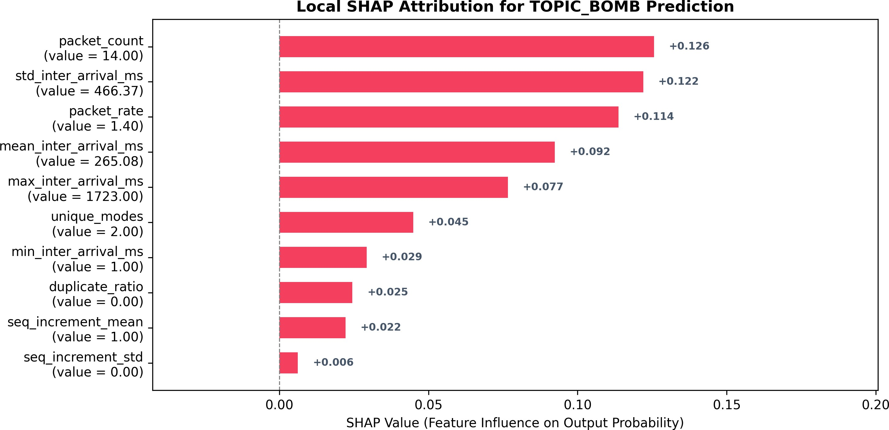

Fig. 9. Local SHAP explanation for a Slow Rate Attack, identified by the extreme 10,000 ms inter-arrival time.
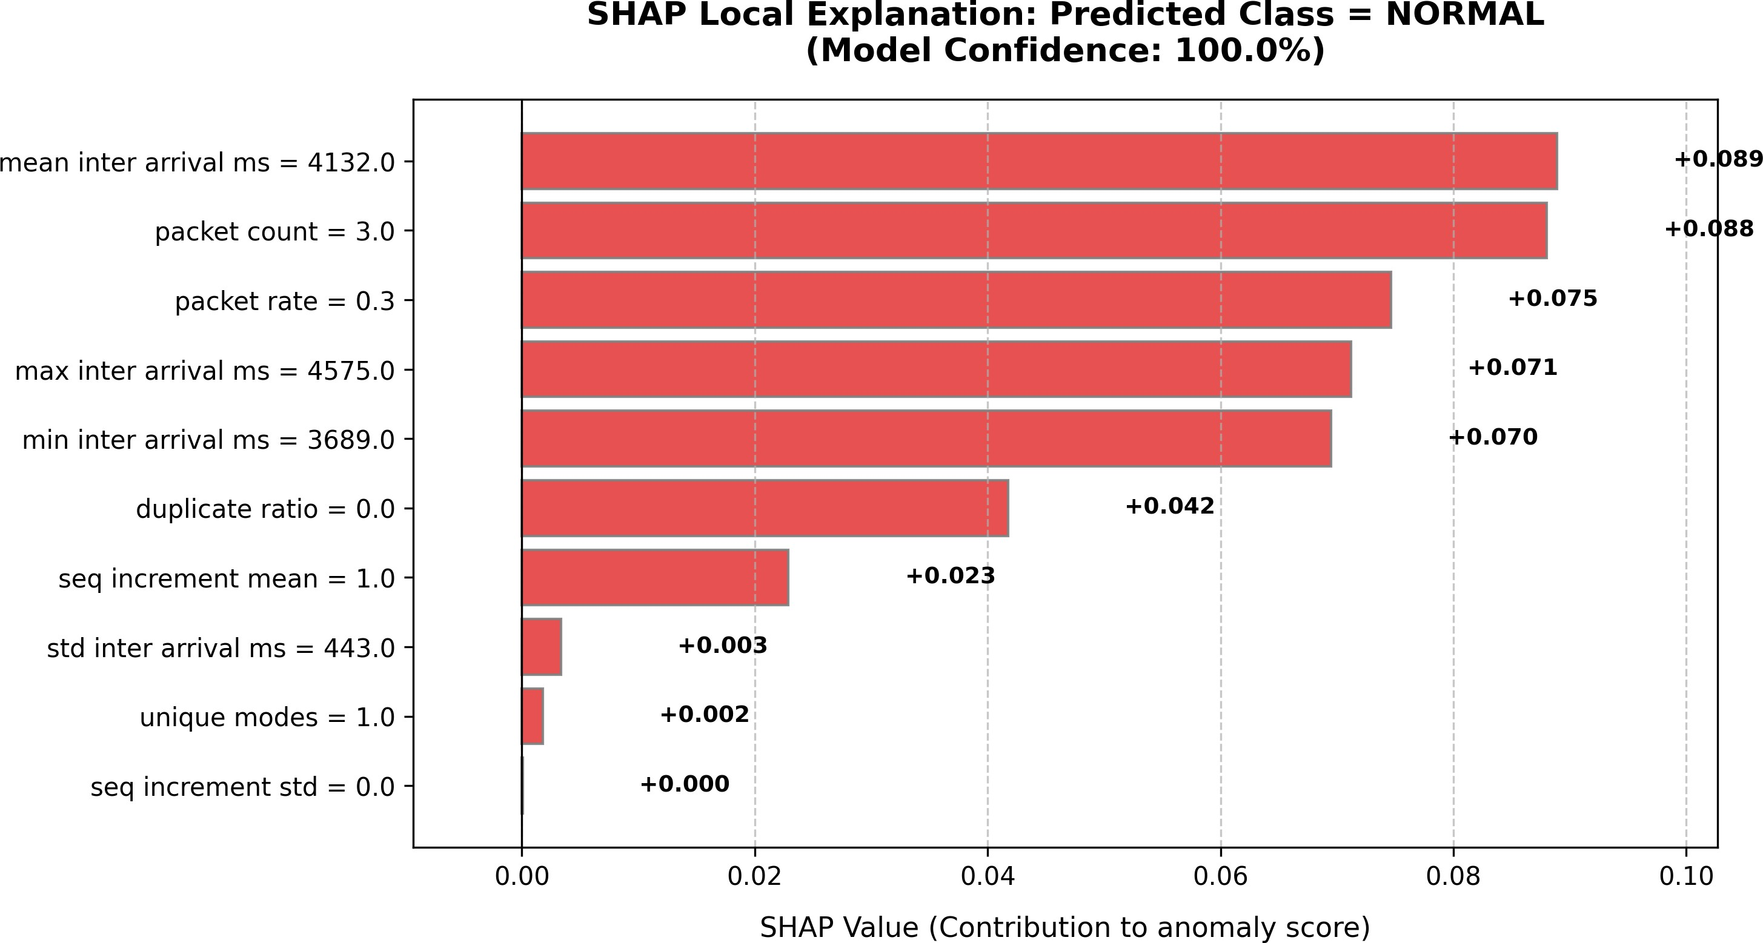

Fig. 10. Local SHAP explanation for Normal traffic, supported by standard timing gaps and low packet frequencies.

- RAG-Driven Analyst Narratives
Even with SHAP, you still have to look at numbers to figure out what’s wrong. We figured it would be much better if an LLM could just explain it to us using a RAG setup. Whenever it spots an attack, the system builds a really detailed prompt in the background. It grabs the classification, the top three SHAP drivers, and the last 50 MQTT packets. We ground the prompt using a local markdown file (DATASETS.md) that has notes on all the attack types. I put a 60-second cooldown on this so we don’t blow through API rate limits.
Fig. 12. Local SHAP explanation for a Topic Bombing classification, dominated by unique modes and count features.
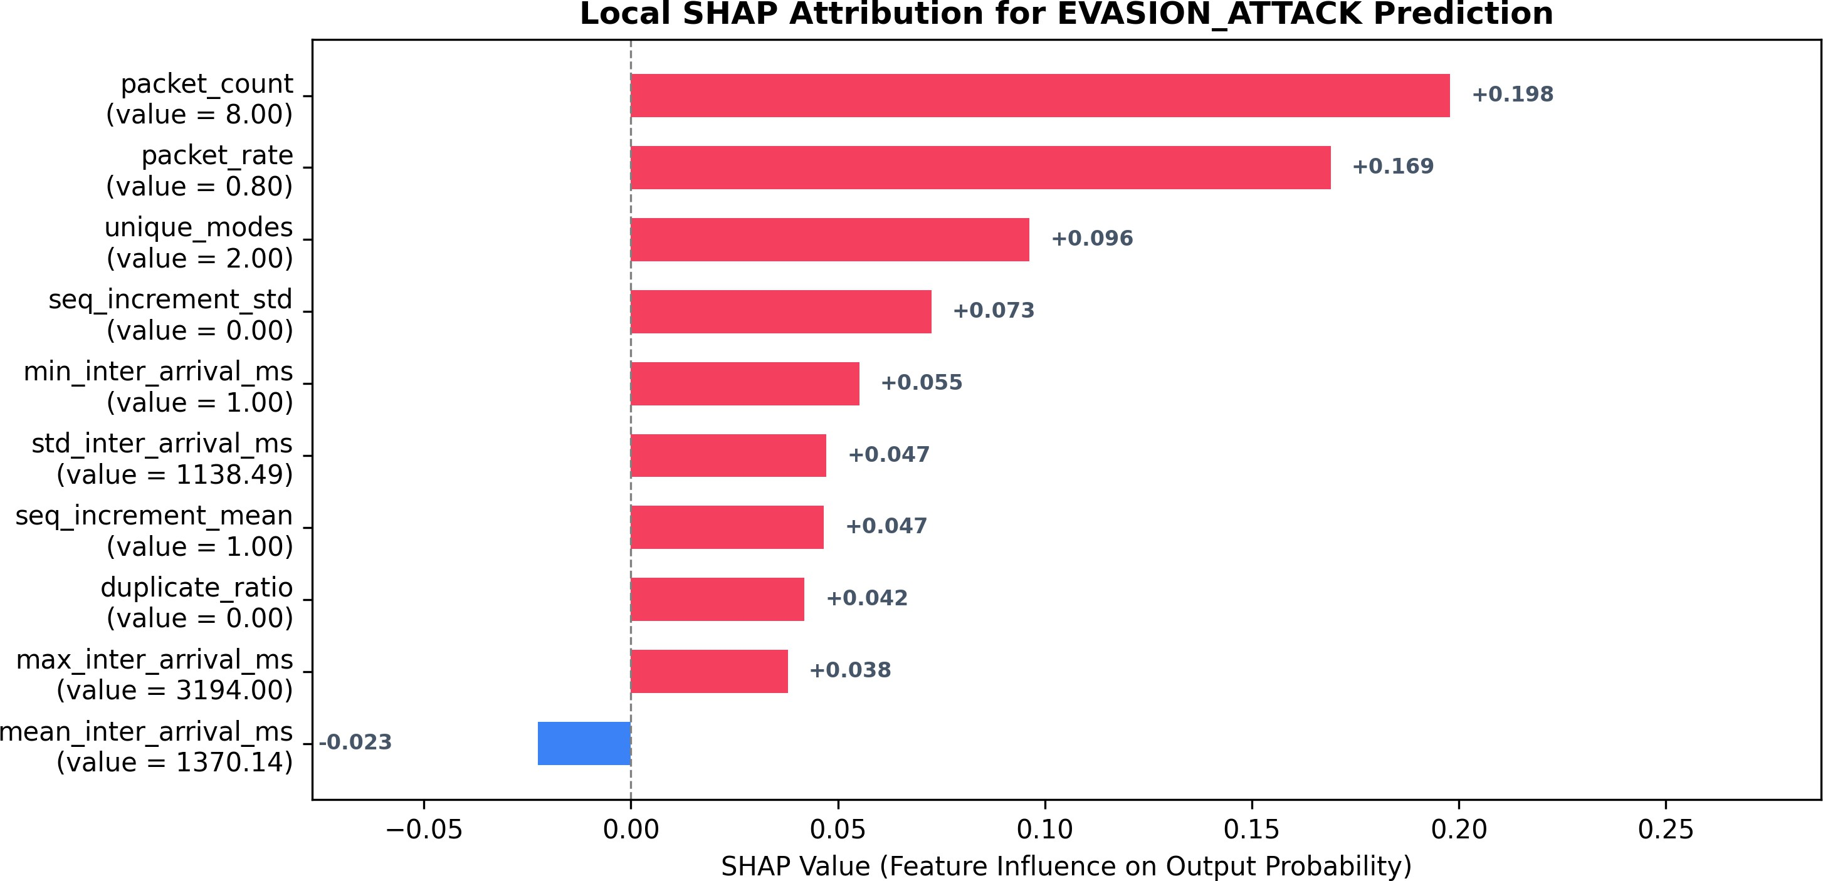

Fig. 13. Local SHAP explanation for an Evasion Attack, driven by the standard deviation of inter-arrival times.

I spent some time making sure the API calls wouldn’t just fail randomly, so it uses a cascade:
- Groq API client: It first tries to query Llama 3.3 70B while rotating through a few API keys. If it hits a rate limit, it falls back to smaller Llama models.
- Google Gemini API client: If Groq is completely down, it makes an async call to Gemini Flash instead.
- Expert System Fallback: If the Wi-Fi drops or every-thing else fails, I wrote a simple parser that writes a basic markdown report locally using whatever is in the current state dictionary.
Finally, the system broadcasts the text via WebSocket to the dashboard. It turns all that complicated math into a plain English report that a Tier-1 SOC analyst could read in a few seconds.

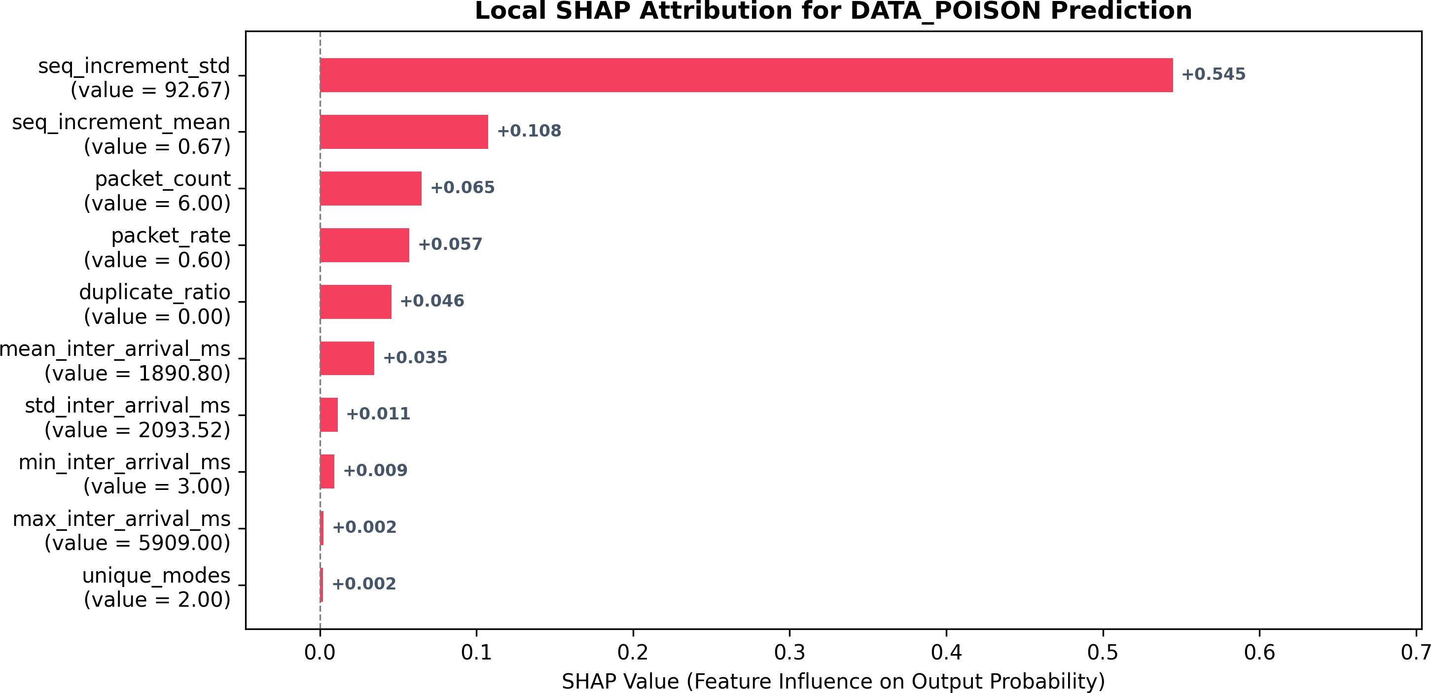
Fig. 11. Local SHAP explanation for a Data Poisoning classification, showcasing the deterministic rule-engine override.
- Conclusion and Future Work
NetGuard AI demonstrated that ML based IoT IDS can actually be run with close to perfect accuracy (99.20%) on real-world live edge hardware and explain its every decision. Instead of parsing the packet payload for unnecessary infor-mation, focusing on behavior within small windows of time was shown to be much more effective. Our Two-Stage Hybrid Detection Pipeline identified both the ”loud” and ”stealthy” attacks. The statistical stage successfully detected the Slow-Rate gaps and Data Poisoning abnormalities while the Random Forest successfully detected DoS Floods, Replay, Topic Bombs

and Evasion. Combined with our XAI stack and having an LLM generate the reports, this significantly offloads the SOC analysts and actually makes raw data useful.
Further work would involve having a larger number of physical nodes for the ESP32 attacker to better simulate the conditions of a DDoS attack and investigate specific MQTT exploits such as sending Malformed Topic. Eventually the experiment would need to be moved off a public broker to a private broker with TLS and mTLS.
References
- Al Hanif, A., & Ilyas, M. (2024). Enhance the Detection of DoS and Brute Force Attacks within the MQTT Environment through Feature Engineering and Employing an Ensemble Technique. arXiv e-prints, arXiv:2408.xxxxx.
- Thanh Binh, B. N., Hoai Luan, P., Duong, L. V. T., Hai, V. T., & Nakashima, Y. (2026). A Protocol-Aware P4 Pipeline for MQTT Security and Anomaly Mitigation in Edge IoT Systems. arXiv e-prints, arXiv:2601.xxxxx.
- Venaˆncio, R., Sousa, C., Duarte, F., & Ribeiro, L. (2026). Secu-rity Analysis of a Communication Protocol: MQTT. arXiv preprint arXiv:2605.15804.
- Hindy, H., Bayne, E., Bures, M., Atkinson, R., Tachtatzis, C., & Bellekens, X. (2020, September). Machine learning based IoT intrusion detection system: An MQTT case study (MQTT-IoT-IDS2020 dataset). In International Networking Conference (pp. 73–84). Cham: Springer International Publishing.
- Sharma, D. P., Xue, L., Sun, X., Lin, X., & Xiong, P. (2025). Enhancing Adversarial Robustness of IoT Intrusion Detection via SHAP-Based Attribution Fingerprinting. arXiv preprint arXiv:2511.06197.
- Aslam, A., Hassan, M., Zahra, B., & Shahzad, M. K. (2026). XAI-SOH-FL: Enhancing SOH-FL with Adaptive Aggregation and Explain-able AI for Intrusion Detection in Heterogeneous IoT. arXiv preprint arXiv:2606.00134.
- Houssel, P. R., Singh, P., Layeghy, S., & Portmann, M. (2024, De-cember). Towards explainable network intrusion detection using large language models. In 2024 IEEE/ACM International Conference on Big Data Computing, Applications and Technologies (BDCAT) (pp. 67–72). IEEE.
- Yang, S., Zheng, X., Zhang, X., Xu, J., Li, J., Xie, D., et al. (2025). Large language models for network intrusion detection systems: Foundations, implementations, and future directions. arXiv preprint arXiv:2507.04752.
- Houssel, P. R., Layeghy, S., Singh, P., & Portmann, M. (2026). ex-nids: A framework for explainable network intrusion detection leveraging large language models. Computers and Electrical Engineering, 129, 110826.
- Biswas, U., Hasan, S., Farhan, S. M., Pillai, N., & Gudla, C. (2026, February). Attribution-Driven Explainable Intrusion Detection with Encoder-Based Large Language Models. In SoutheastCon 2026 (pp. 1–8). IEEE.
- Akif, M. A., Butun, I., Williams, A., & Mahgoub, I. (2025). Hybrid machine learning models for intrusion detection in IoT: Leveraging a real-world IoT dataset. arXiv preprint arXiv:2502.12382.
- Qaddoori, S. L., & Ali, Q. I. (2025). An efficient security model for industrial internet of things (IIoT) system based on machine learning principles. arXiv preprint arXiv:2502.06502.
- Antonini, M., Pincheira, M., Vecchio, M., & Antonelli, F. (2023). An adaptable and unsupervised TinyML anomaly detection system for extreme industrial environments. Sensors, 23(4), 2344.
- Hossain, M. A., Ishtiaq, W., & Islam, M. S. (2026). A Comparative Analysis of Ensemble-Based Machine Learning Approaches With Ex-plainable AI for Multi-Class Intrusion Detection in Drone Networks. Security and Privacy, 9(1), e70164.
- Vaccari, I., Aiello, M., & Cambiaso, E. (2020). SlowITe, a novel denial of service attack affecting MQTT. Sensors, 20(10), 2932.

